The South African Institute of Agricultural Engineers and 6th Pan African Society for Agricultural Engineering International Symposium

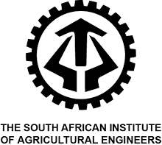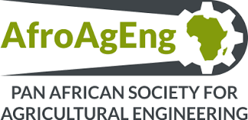

23 – 25 October 2024
Engineering within the Agricultural Environment

The culmination of 60 years of Agricultural Engineering excellence with SAIAE!

Call for Abstracts Form

Title of Paper:
Authors:
(Initials and Surnames)
Corresponding author’s title, first
name and surname:
Designation (consultant, researcher,
student etc.)
Company / Institution:
Address:
Phone number:
Email address:
Please indicate if you would prefer a
poster or oral presentation
List four keywords

Please take note of the following:

Abstracts should be submitted accompanied by this form.
Abstracts should be in Calibri font, a font size of 12 with single spacing and must be justified.
Abstracts should be no longer than 300 words and include a suitable title as well as a photo.

Insert Abstract Below

Please note that all abstracts must be submitted to senzo@saiae.co.za or londiwe@saiae.co.za by no later than 16 August 2024.

